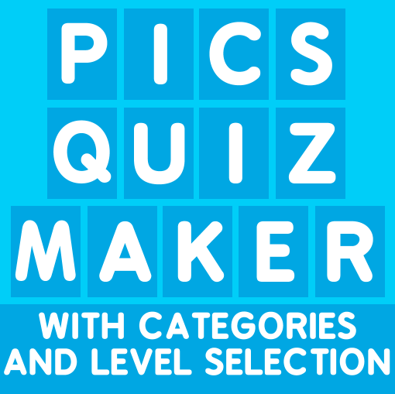

HOW TO USE

www.ekume.com

**Do you have problems or questions?, Write us a private message in our facebook page:** [**https://www.facebook.com/pages/Ekume-Games/404902703053414**](https://www.facebook.com/pages/Ekume-Games/404902703053414)

|  |  |
| --- | --- |
| TITLE | PAGE |
| Categories (Add new categories) | 2 |
| Configurations (Value of the coins) | 3 |
| How to change/add/delete words | 4 |
| How to change or add new images | 5, 6 |
| How to add translations | 7 |
| How to change the translations of the UI | 8 |
| How to add information about the image | 9 |
| How to change the sounds of the game | 10 |
| Change URL of facebook page and web page. | 11 |
| Tools | 12 |

**CATEGORIES**

1. Deleting default categories:

* Click on this objects and delete with the “Supr” button (Of your keyboard)

*Warning!: Never delete the object “Words_Database”, this is the principal object.*

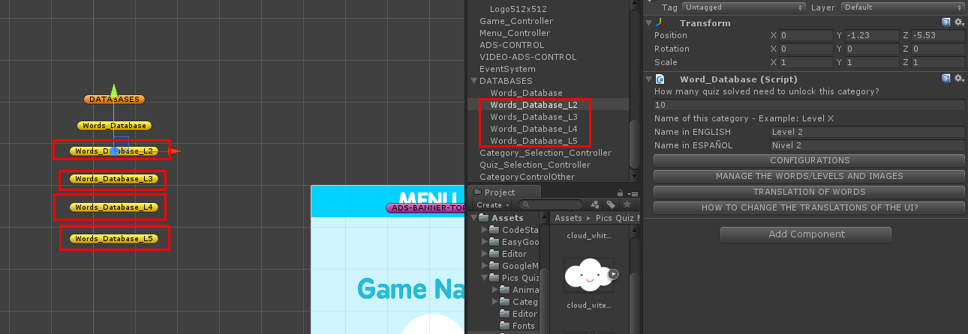

1. Create new categories

* To create your own categories click on “Words_Database” object and press Ctrl+D to duplicate this category. Each object that you clone of this is one category.
* (You can select the object and press the W key of your keyboard and move down the object to have an order of the categories)

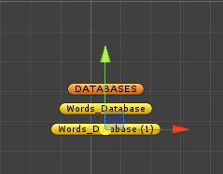

Click on the object with the category that you want change to show all options to do the changes in the game content.

**Configurations:**

***Warning!: You should be the same values of the configurations on all categories!***

Here you can change the value of the coins and define if you want show information about the image later that the player solve one quiz.

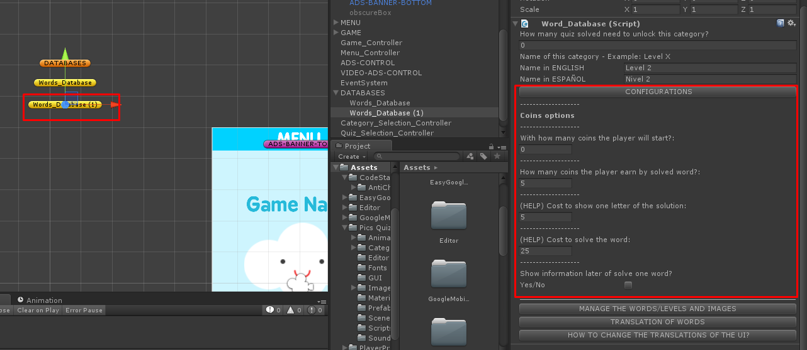

**How to change/add/delete words:**

Press the button “MANAGE THE WORDS”.

Here you can edit or delete the words.

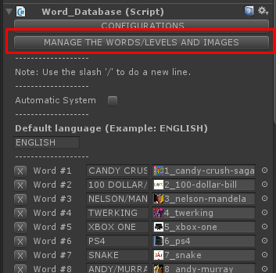

To add new words press the button ADD NEW WORD:

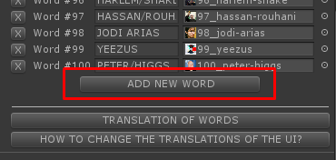

**How to change or add new images:**

Drag and drop the images that you want add to the game into the folder Images.

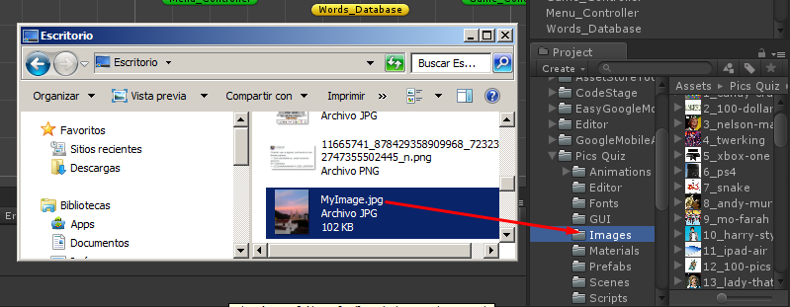

Select the images added before and do these changes:

* Generate Mip Maps = false.
* Max Size = 256
* Format = Compressed

Click on Apply

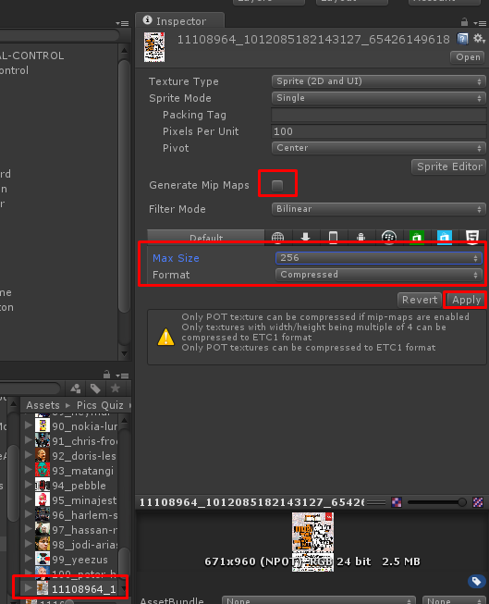

Now go to the category and drag and drop the sprite on the level that you want change. (Remember that you need do click on the  icon to see the sprite)

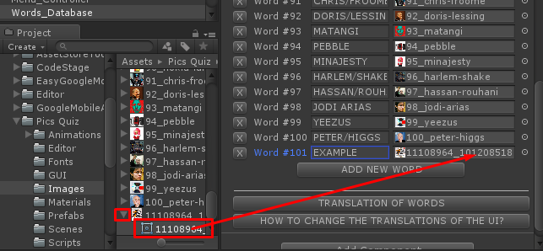

**How to add translations:**

Click on the button TRANSLATION OF WORDS and do click on ADD NEW LANGUAGE.

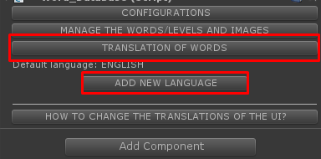

Now you can put the name of the language and add the corresponding translations of the words:

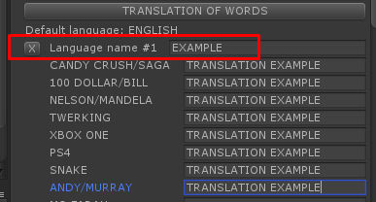

Now the player can select the language on the menu.

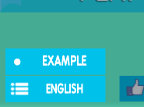

**How to change the translations of the UI**

1. Open the “Scripts” folder
2. Open Word_Database script.

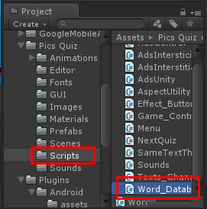

1. Read the instructions of the commented lines.

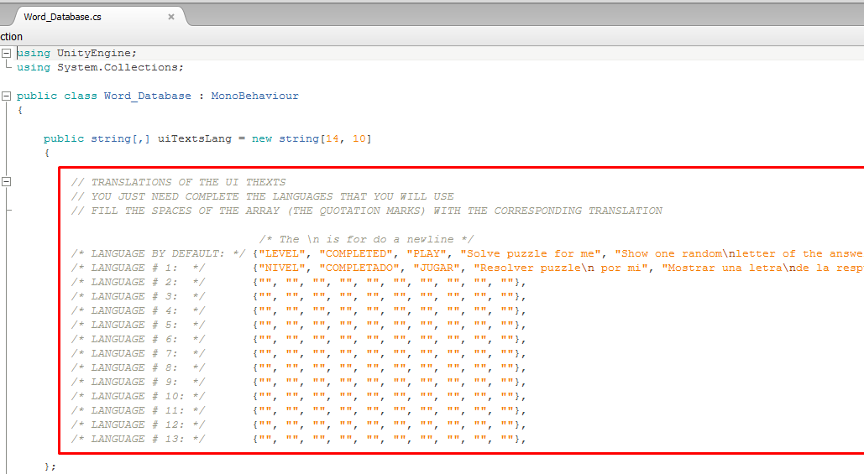

**How to add information about the image when the player solves one quiz:**

Put enable the option in the configurations

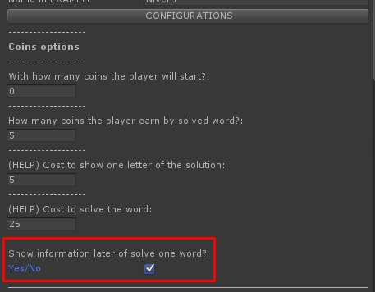

Now appear the button “QUIZ INFORMATIONS” and you can put the information on each language that you have in the game!:

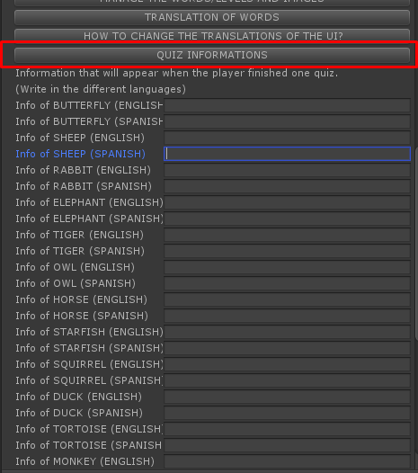

**How to change the sounds of the game**

1. You will need have the sounds that you want in the game if you want to change the actual sounds.
2. Later that you have the sounds, drag and drop your sounds into the “Sounds” folder.

The supported formats of sounds:

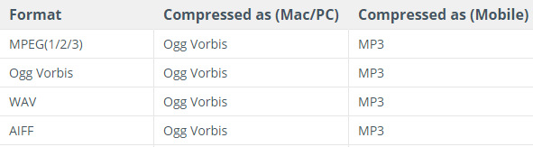

1. Select the camera
2. Drag and drop the sounds into the correspondent spaces.

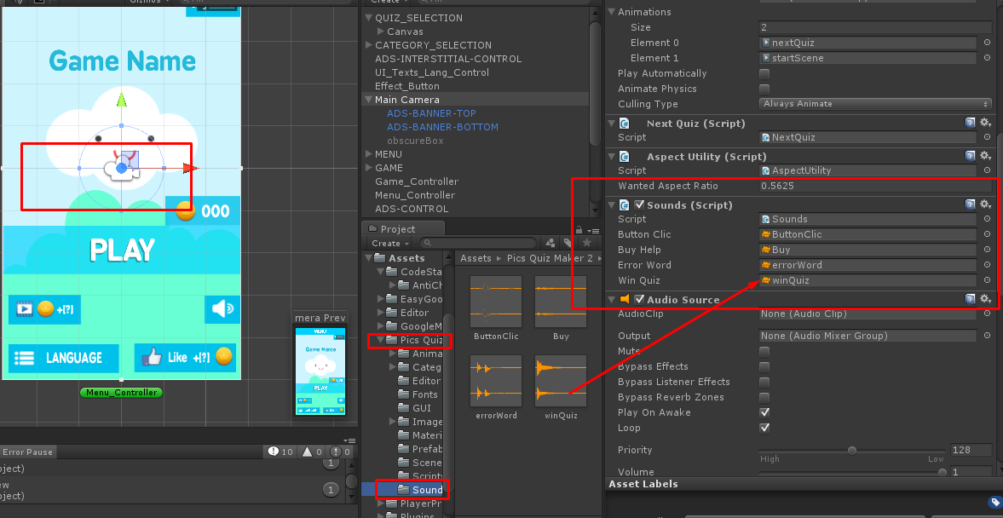

**Change URL of facebook page and web page.**

* To change the URL of facebook or web page select the button Menu_Controller.
* Here you can change the number of coins that you want give when the player do click on the like button in the game.

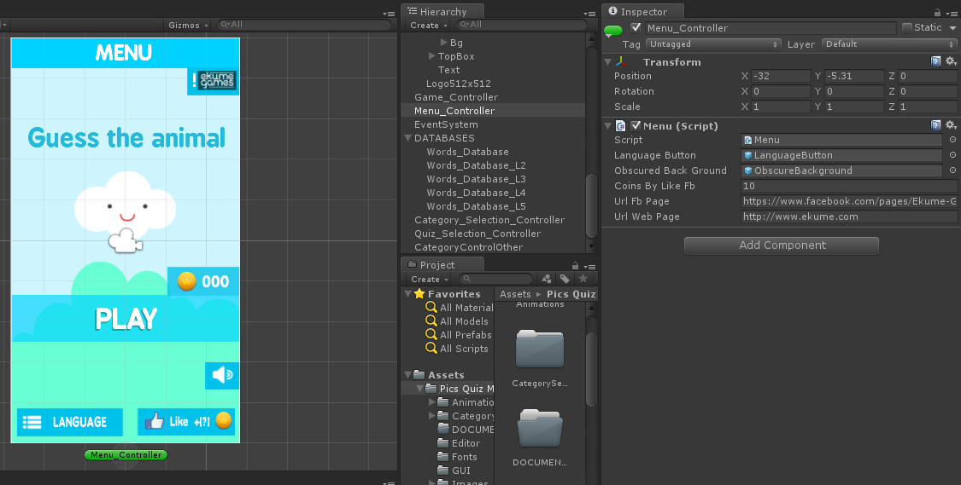

**Tools**

* With this tools you can do testing more easy!

